Appsters Industry Page Layout
REAL ESTATE
Laid out fold by fold against www.appsters.io/industry
 | DETAIL
Slug | real-estate-app-development
Meta Title | Real Estate App Development Company | Appsters
Meta Description | Appsters builds property listing, brokerage CRM and proptech apps with live MLS sync and fast media loading. Request a free proposal from our team.
Layout Source | www.appsters.io/industry
Live Folds | 23
New Blocks Required | 3
FOLD 1: Hero Banner
Hero Banner
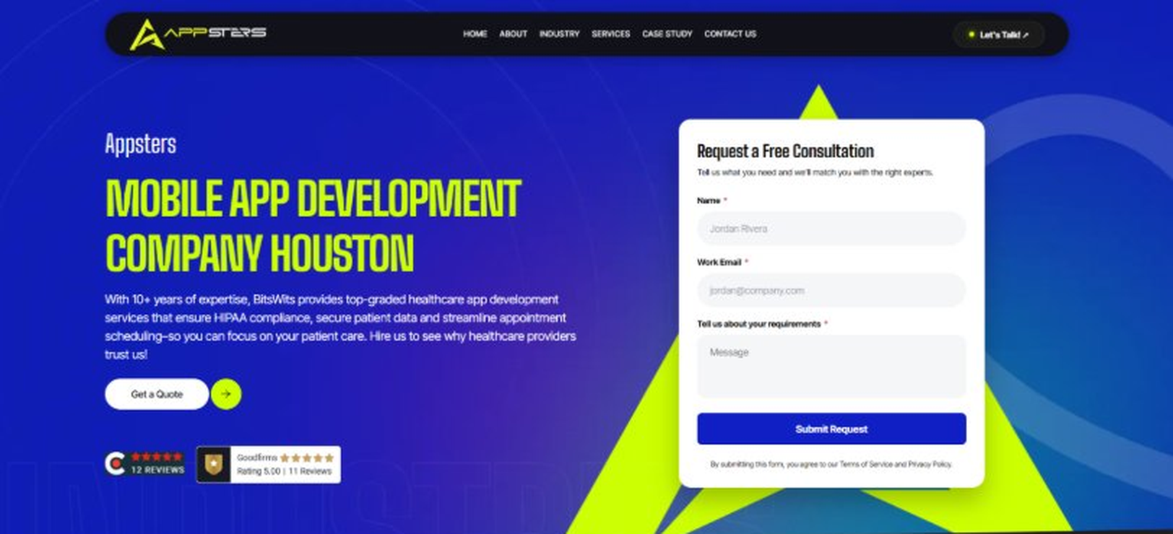
Current live page, www.appsters.io/industry
 | DETAIL
Status | New copy applied
Build Notes | Live block holds H1, sub copy, a Get a Quote button and the Request a Free Consultation form. New copy supplies the H1 and sub copy only.
QA Flag | Live hero copy currently names BitsWits and describes healthcare services. Leftover copy from another build, replace it with the new copy below.
Copy For This Fold
PAGE ELEMENT | COPY (WORD FOR WORD)
H1 (Page Heading) | A Real Estate App Development Company Building Platforms That Close Deals Faster
Body Copy | Listings go stale the moment they stop updating in real time, and buyers notice. As a real estate app development company, Appsters builds Real Estate apps that keep listings accurate, communication instant, and transactions moving without the usual back-and-forth. We build platforms for brokerages, property managers, and proptech startups who need software that actually shortens the sales cycle.
FOLD 2: Marquee Strip
Marquee Strip: Turn Your Wildest Ideas Into Powerful Digital Products
Current live page, www.appsters.io/industry
 | DETAIL
Status | No copy change
Build Notes | No new copy in the source document for this fold. Keep the live block exactly as it is.
FOLD 3: Stats Counter
Stats Counter: Work With A Local Mobile App Developer In Houston
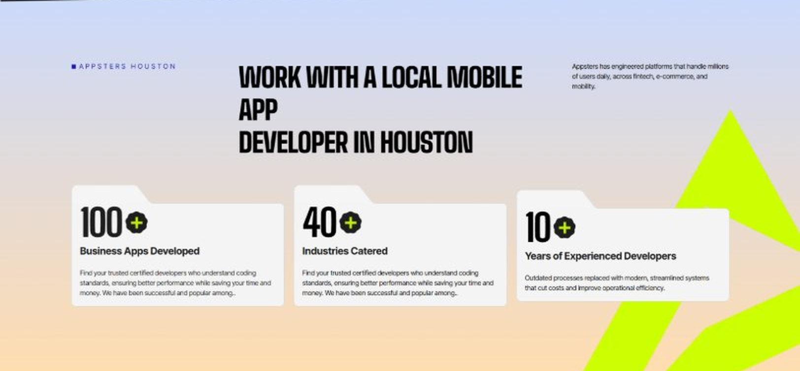
Current live page, www.appsters.io/industry
 | DETAIL
Status | New copy applied
Build Notes | Live block holds 3 counters. New copy holds 6 stats. Either widen the block to 6 or drop two.
Copy For This Fold
PAGE ELEMENT | COPY (WORD FOR WORD)
H2 (Section Heading) | Awarded For Building Real Estate Apps That Turn Listings Into Closings
Body Copy | Our Real Estate app development work has earned recognition for listing accuracy, lead response speed, and measurable conversion gains for agents. Appsters has been recognized for delivering platforms that sync MLS data reliably, handle high-resolution media without slowdown, and stay stable through seasonal listing surges. Every award reflects tested performance, not a glossy brochure.
Stat 1 Number | 40+
Stat 1 Label | Industries Served
Stat 1 Copy | Our experience spans social platforms, marketplaces, fintech, healthcare, and more, with solutions adapted to each sector's demands for security, AI, compliance, and user adoption.
Stat 2 Number | 3000+
Stat 2 Label | Apps and Solutions Delivered
Stat 2 Copy | Thousands of projects executed with an emphasis on speed, AI adoption, stability, and clear ROI across both startup and enterprise environments.
Stat 3 Number | 60+
Stat 3 Label | AI Models Deployed
Stat 3 Copy | Every model is designed for high accuracy, reliable outputs, and performance at scale for mission-critical workflows and more.
Stat 4 Number | 50,000+
Stat 4 Label | Legacy Processes Modernized
Stat 4 Copy | Outdated processes replaced with modern, streamlined systems that cut costs and improve operational efficiency.
Stat 5 Number | 250+
Stat 5 Label | Engineers and Designers
Stat 5 Copy | A global team skilled in native mobile app development, AI-driven ecosystems, cross-platform builds, and enterprise architecture.
Stat 6 Number | 95%
Stat 6 Label | Client Retention
Stat 6 Copy | Long-term partnerships built on trust, consistent delivery, and continuous optimization of live applications.
FOLD 4: Marquee Strip
Marquee Strip: Mobile App Development Services
Current live page, www.appsters.io/industry
 | DETAIL
Status | No copy change
Build Notes | No new copy in the source document for this fold. Keep the live block exactly as it is.
FOLD 5: Services Grid
Services Grid: Our Comprehensive Mobile App Development Services In Houston
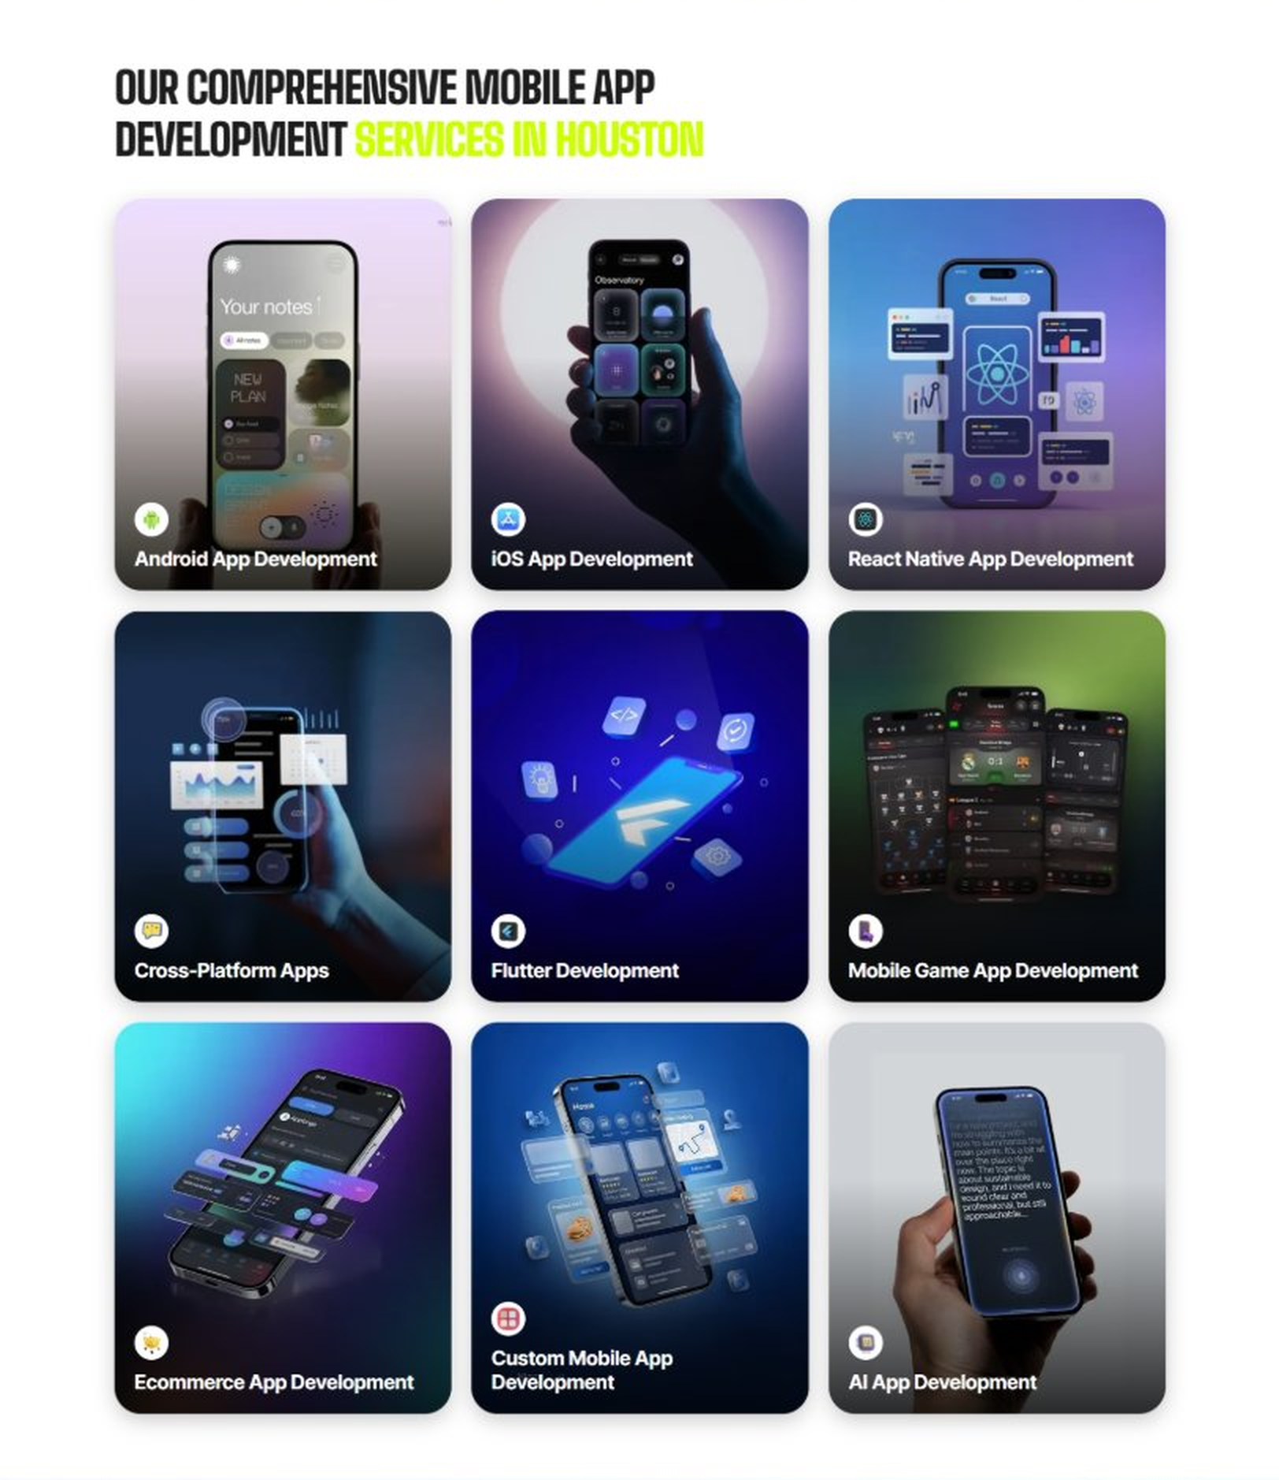
Current live page, www.appsters.io/industry
 | DETAIL
Status | New copy applied
Build Notes | Live grid holds 9 cards. New copy holds 5 services. Either trim the grid to 5 or brief four more services.
Copy For This Fold
PAGE ELEMENT | COPY (WORD FOR WORD)
H2 (Section Heading) | Real Estate Application Development Services Built For Agents Who Close Faster
Body Copy | Strong real estate platforms sit at the crossroads of listing data, media, and communication. As a real estate app development company, we connect market knowledge with technical precision. Appsters' senior developers build platforms that support live MLS sync, virtual tours, and secure document handling for agents, brokerages, and buyers.
Service 1 Heading | Real Estate Finder App Development
Service 1 Copy | As Real Estate app developers, we build discovery tools that help buyers filter listings by the details that actually matter to them, from commute time to school zones, replacing generic search filters with something people actually use.
Service 2 Heading | Food Ordering App Development
Service 2 Copy | Mixed-use developments and residential communities increasingly bundle amenities with their resident apps, and our food ordering app developers know how to build ordering flows that plug directly into a property management platform.
Service 3 Heading | Food Delivery App Development
Service 3 Copy | As a food delivery app development company, we build fulfillment layers that connect building concierge services to resident apps, giving property managers one system for deliveries instead of juggling separate vendor tools.
Service 4 Heading | Discounts App Development
Service 4 Copy | Our Real Estate discounts app development work helps property managers and brokerages reward repeat clients and long-term tenants with referral perks and lease renewal incentives built directly into the app.
Service 5 Heading | Real Estate Review & POS Software Development
Service 5 Copy | For property management offices, our POS software development company expertise connects rent payments, maintenance billing, and tenant reviews into one system, so managers see accurate numbers without chasing paper receipts.
FOLD 6: Case Study CTA
Case Study CTA: HELPP
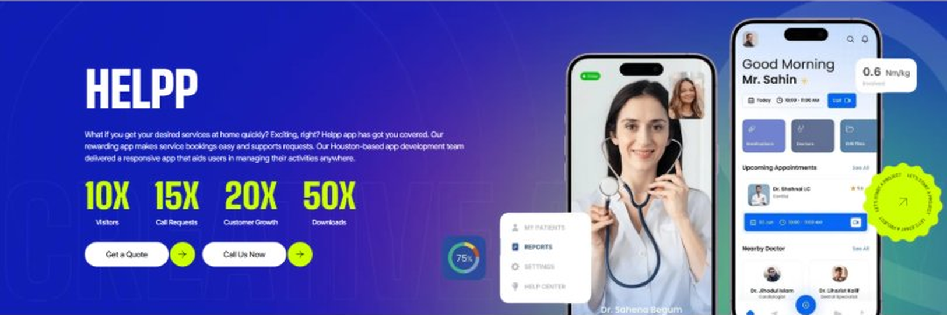
Current live page, www.appsters.io/industry
 | DETAIL
Status | New copy applied
Build Notes | Live block holds a product name, a paragraph, four metric counters and two CTA buttons. New copy supplies the heading and paragraph. Metrics still need to be supplied.
Copy For This Fold
PAGE ELEMENT | COPY (WORD FOR WORD)
H2 (Section Heading) | Real Estate App Developers Who Build For Speed, Not Just Sizzle
Body Copy | Launching a listing app is easy. Getting agents and buyers to actually rely on it is the hard part. If you're ready to build Real Estate apps that shorten your sales cycle, Appsters is the partner that gets you there. Let's talk about your market, your workflow, and what a platform built to last actually requires.
FOLD 7: Testimonials
Testimonials: Real Stories From People Who Wanted What’s Next
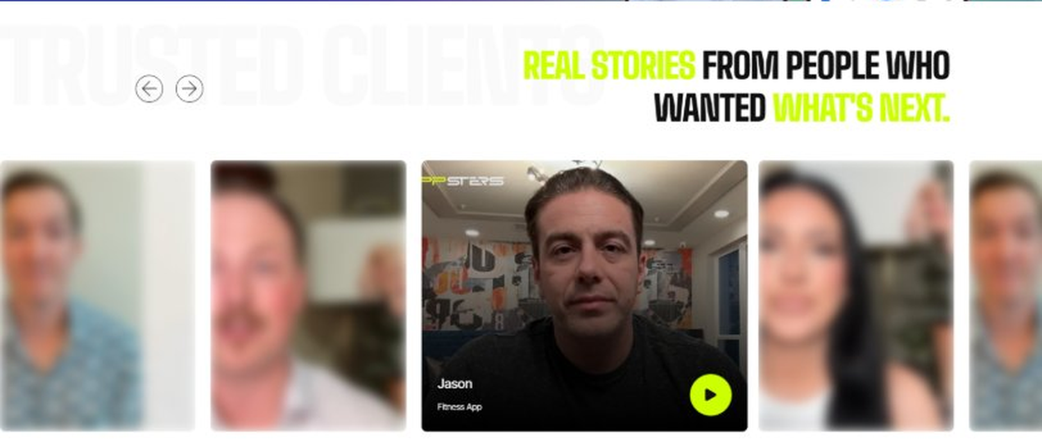
Current live page, www.appsters.io/industry
 | DETAIL
Status | New copy applied
Build Notes | Live block runs video testimonials. New copy is written quotes with attributions. Source document marks this fold design TBD.
Copy For This Fold
PAGE ELEMENT | COPY (WORD FOR WORD)
H2 (Section Heading) | What Our Clients Say
Testimonial 1 Quote | "Our agents were manually updating listings on four different sites before this. Now it happens automatically, and nobody has to remember to do it, which honestly should have happened years ago."
Testimonial 1 Attribution | Bradley Simms, Managing Broker
Testimonial 2 Quote | "I was skeptical a virtual tour feature would actually cut down on wasted showings. It did, almost immediately, and our agents have more time now to focus on buyers who are actually ready."
Testimonial 2 Attribution | Yvonne Castellano, Director of Operations
Testimonial 3 Quote | "Rent collection used to mean chasing checks and updating spreadsheets by hand every month. That whole process basically runs itself now, and our maintenance response time improved as a side effect."
Testimonial 3 Attribution | Harold Mbeki, Property Manager
Testimonial 4 Quote | "We needed fair housing compliance built into the app from day one given how strict our market's regulations are. Appsters got that right without us having to spell it out twice."
Testimonial 4 Attribution | Danielle Foss, Compliance Officer
Testimonial 5 Quote | "What surprised me was how the closing tool held up during our busiest month ever. Every document, every signature, tracked correctly. That's not something I expected from a first release."
Testimonial 5 Attribution | Preston Kowalski, Chief Operating Officer
Source document note: Testimonial fold, design TBD after content
FOLD 8: Technology Logo Strip
Technology Logo Strip

Current live page, www.appsters.io/industry
 | DETAIL
Status | No copy change
Build Notes | No new copy in the source document for this fold. Keep the live block exactly as it is.
FOLD 9: Why Choose Us
Why Choose Us: Compelling Reasons To Choose Us As A Trustable App Development Company In Houston
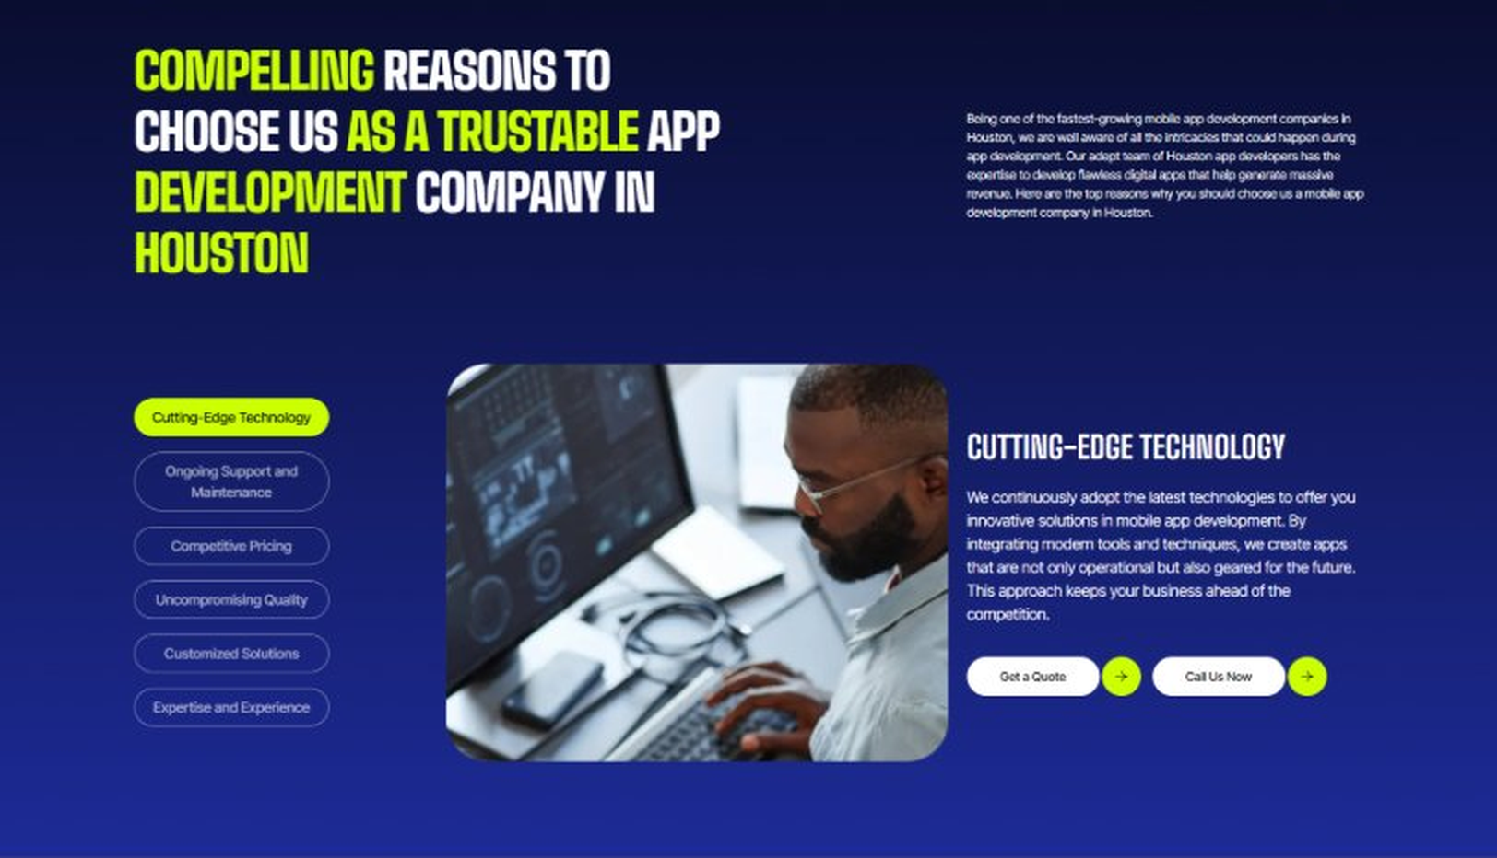
Current live page, www.appsters.io/industry
 | DETAIL
Status | New copy applied
Build Notes | Live block holds 6 tabs. New copy holds 6 reasons. Clean one to one fit, no design change needed.
Copy For This Fold
PAGE ELEMENT | COPY (WORD FOR WORD)
H2 (Section Heading) | Why Brokerages And Property Managers Choose Appsters As Their Trusted Real Estate App Partner
Body Copy | Choosing a real estate app development partner shapes whether your agents close faster or keep losing leads to slow follow-up. Our team blends market knowledge, engineering discipline, and data accuracy to build apps agents actually use.
Reason 1 Heading | Accuracy-First Architecture
Reason 1 Copy | We design every feature around real-time listing accuracy, backed by live MLS sync rather than overnight batch updates.
Reason 2 Heading | Built-In Compliance Logic
Reason 2 Copy | Fair housing rules and disclosure requirements aren't bolted on later. Our systems are built around compliant workflows from the first wireframe.
Reason 3 Heading | Peak-Season Engineering
Reason 3 Copy | Our architecture is stress-tested for busy selling seasons, so a surge in listing activity becomes a good problem, not an outage.
Reason 4 Heading | Agent-First Usability
Reason 4 Copy | From lead alerts to document signing, we design agent-facing tools simple enough to use between showings, not just at a desk.
Reason 5 Heading | Transparent Development Cycles
Reason 5 Copy | We follow sprint cadences with review checkpoints and shared roadmaps, so clients always know what's shipping and what's improving.
Reason 6 Heading | Long-Term Platform Thinking
Reason 6 Copy | We structure apps as ecosystems that evolve with portfolio growth and shifting market conditions, built for longevity rather than a single launch cycle.
FOLD 10: Sector Tabs
Sector Tabs: Serving 40+ Sectors With Mobile App Development In Houston
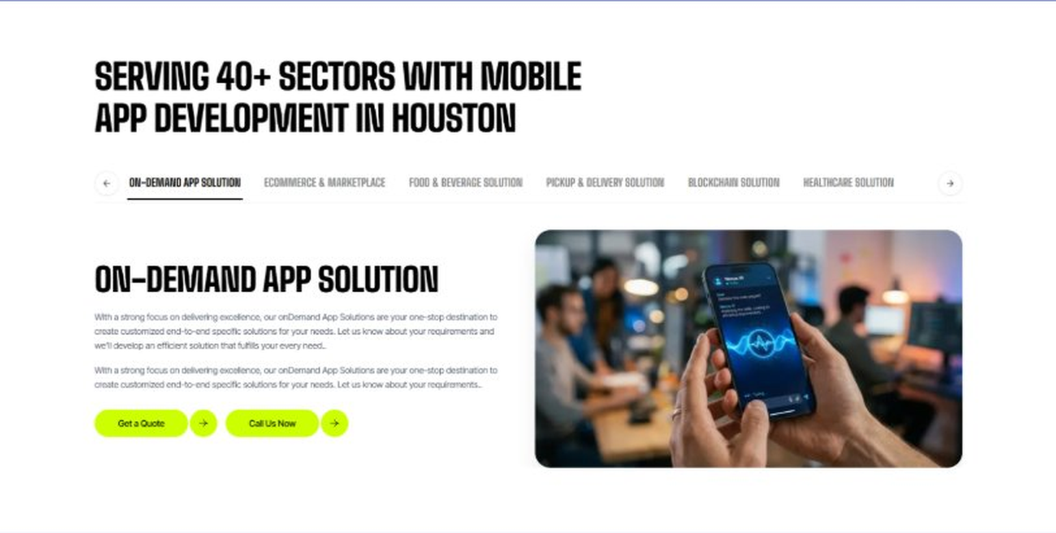
Current live page, www.appsters.io/industry
 | DETAIL
Status | New copy applied
Build Notes | Live block holds 6 sector tabs. New copy holds 5 solutions. Drop one tab or brief a sixth solution.
Copy For This Fold
PAGE ELEMENT | COPY (WORD FOR WORD)
H2 (Section Heading) | Real Estate App Solutions Built For Every Stage Of The Transaction
Body Copy | Appsters delivers Real Estate app solutions that cover everything from property management to closing tools. Our systems are architected by senior Real Estate app developers who focus on data accuracy, speed, and stable performance. Through our Real Estate app development services, we help organizations build platforms that feel modern, trustworthy, and built to scale with a growing portfolio.
Solution 1 Heading | Event Management Apps
Solution 1 Copy | Our event tools help brokerages coordinate open houses and property launch events, managing RSVPs and follow-up communication from a single dashboard.
Solution 2 Heading | Corporate Events Apps
Solution 2 Copy | We build internal event apps for brokerage-wide training sessions and agent conferences, replacing scattered emails with something that actually tracks attendance.
Solution 3 Heading | Subscription-Based Meal Apps
Solution 3 Copy | We build subscription-based amenity tools for residential communities offering meal delivery perks as part of a resident package, all managed through the same app residents already use for rent and maintenance.
Solution 4 Heading | Cloud Kitchen Apps
Solution 4 Copy | We connect cloud kitchen partnerships to multi-unit residential apps, letting property managers offer food delivery amenities without operating a kitchen themselves.
Solution 5 Heading | Inventory Management Apps
Solution 5 Copy | Real-time inventory management keeps available units, model home furnishings, and staging assets accurate across every property a management company oversees.
FOLD 11: Engagement Models Table
Engagement Models Table: Flexible Engagement Models For Any App Development Need
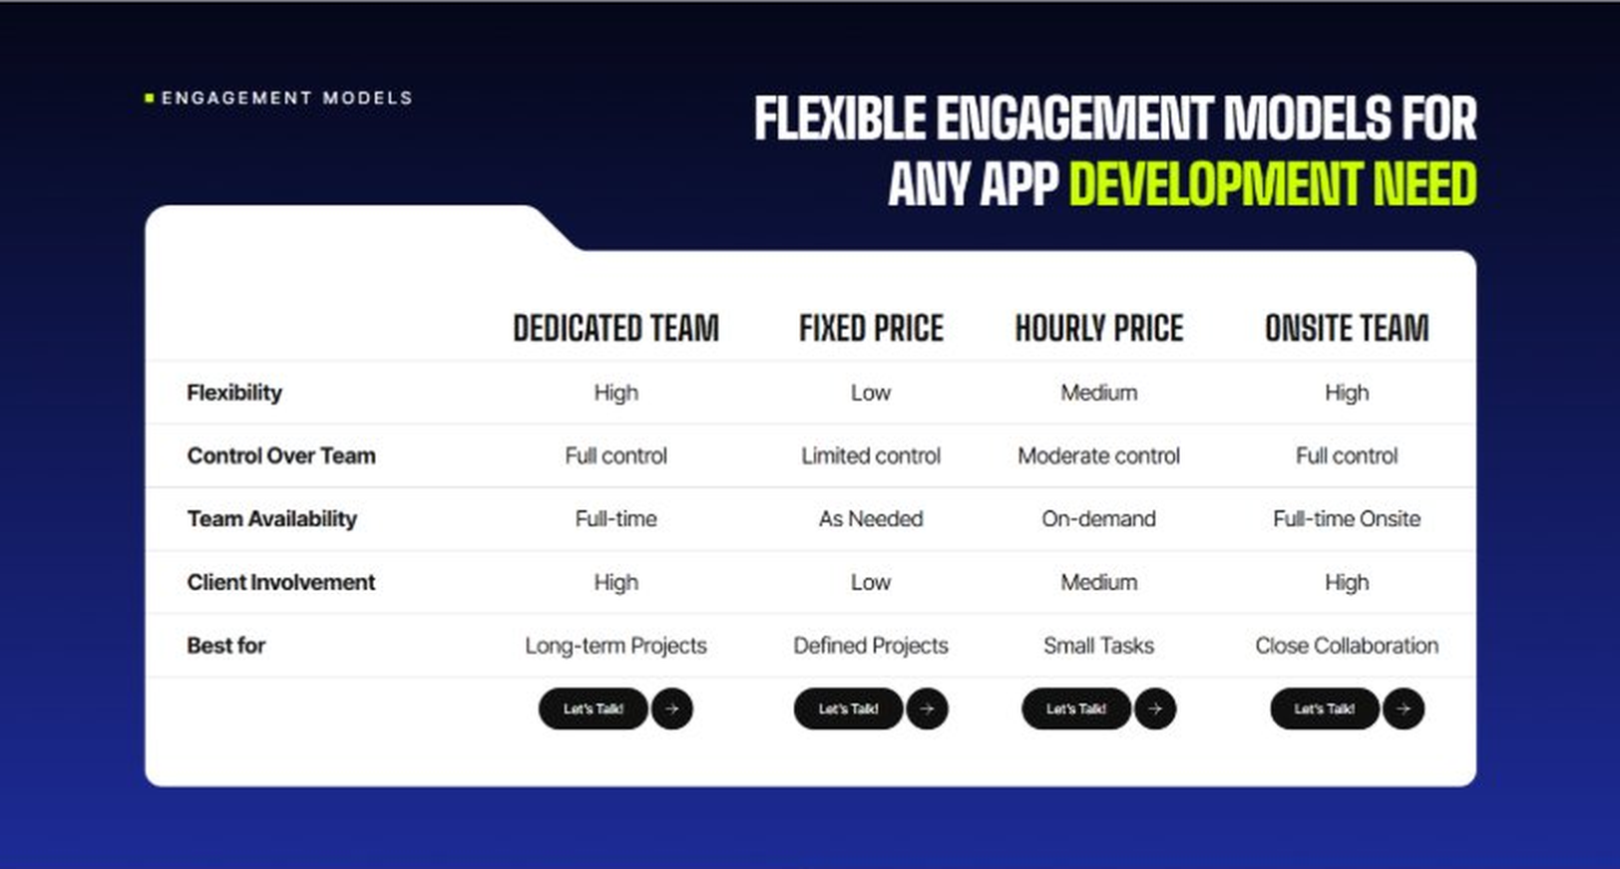
Current live page, www.appsters.io/industry
 | DETAIL
Status | No copy change
Build Notes | No new copy in the source document for this fold. Keep the live block exactly as it is.
FOLD 12: Game App CTA
Game App CTA: Into Engaging Mobile Games
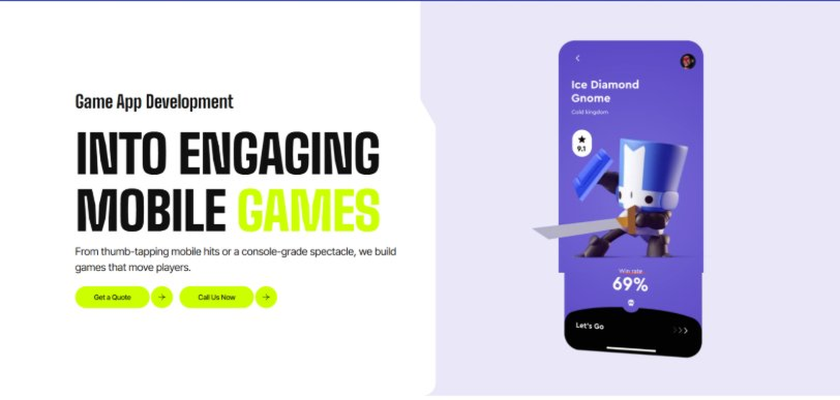
Current live page, www.appsters.io/industry
 | DETAIL
Status | No copy change
Build Notes | No new copy in the source document for this fold. Keep the live block exactly as it is.
FOLD 13: Collaboration And Client Logos
Collaboration And Client Logos
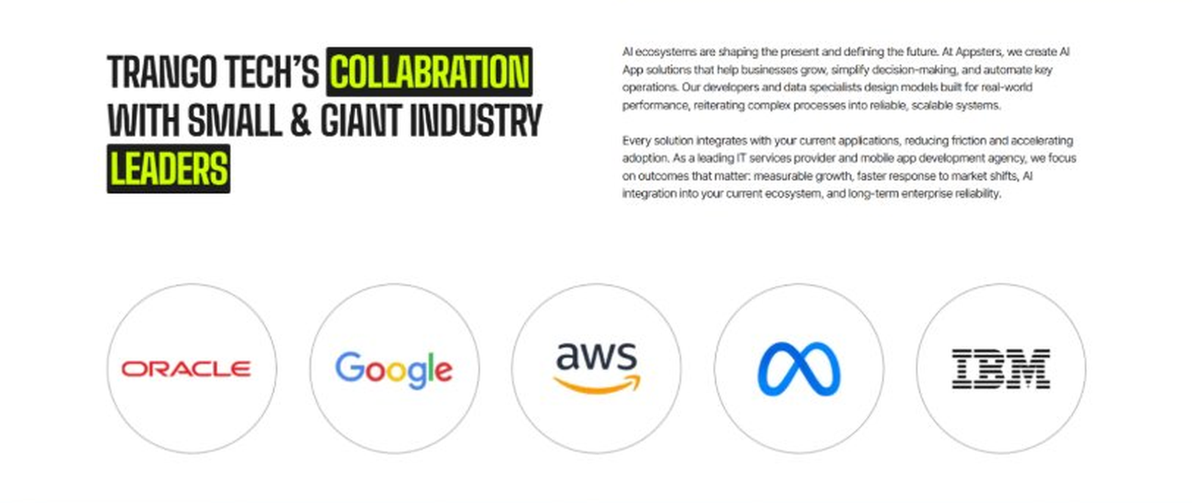
Current live page, www.appsters.io/industry
 | DETAIL
Status | No copy change
Build Notes | No new copy in the source document for this fold. Keep the live block exactly as it is.
QA Flag | Live heading reads "Trango Tech’s Collabration with Small & Giant Industry Leaders". That is a competitor name plus a spelling error sitting live on the page. Fix regardless of this content drop.
FOLD 14: Recognition CTA Banner
Recognition CTA Banner
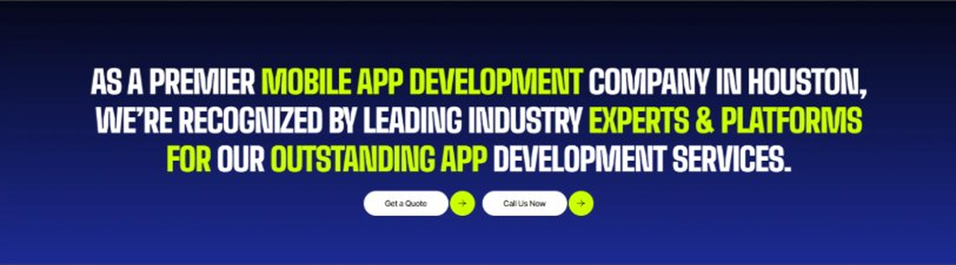
Current live page, www.appsters.io/industry
 | DETAIL
Status | New copy applied
Build Notes | Live block holds a headline and two CTA buttons. New copy supplies the heading and paragraph.
Copy For This Fold
PAGE ELEMENT | COPY (WORD FOR WORD)
H2 (Section Heading) | The Right Buyer Is Searching Right Now. Is Your Platform Ready To Launch?
Body Copy | Every day you wait is a day another brokerage gets ahead on speed and accuracy. Let's build a Real Estate app that keeps your listings sharp and your pipeline moving. Talk to Appsters today, and let's figure out what your first release actually needs to look like.
FOLD 15: Market Presence And Office Map
Market Presence And Office Map: Expand Your Market Presence
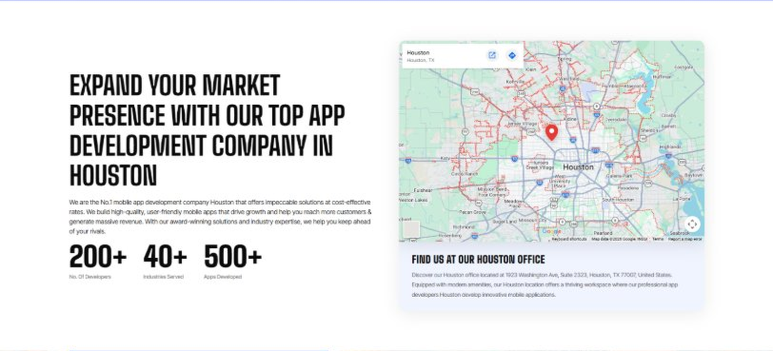
Current live page, www.appsters.io/industry
 | DETAIL
Status | New copy applied
Build Notes | Live block holds a heading, a paragraph, three counters and the office map. New copy supplies the heading and paragraph.
Copy For This Fold
PAGE ELEMENT | COPY (WORD FOR WORD)
H2 (Section Heading) | Food Ordering App Development Company Expertise Behind Every Real Estate Platform We Build
Body Copy | As a team that knows how to develop mobile Real Estate apps at scale, we bring the same rigor to embedded amenity and delivery features. Our engineers have shipped AI-based food delivery apps, resident portals, and property management systems, giving us a deeper bench than studios that only build listing interfaces. React Native, Swift, Kotlin, Node.js, and MLS integration APIs form our core stack, paired with AI models tuned for pricing prediction, lead scoring, and fraud detection. Where most competitors treat amenities as an afterthought, we design them into the resident experience from day one.
FOLD 16: Portfolio
Portfolio: Quick Glimpse On Our Portfolio

Current live page, www.appsters.io/industry
 | DETAIL
Status | New copy applied
Build Notes | Live block holds a heading, a paragraph and one CTA. New copy holds an intro plus 4 named product cards. Source document marks this fold design TBD.
Copy For This Fold
PAGE ELEMENT | COPY (WORD FOR WORD)
H2 (Section Heading) | Real Estate Products Engineered For Faster, Cleaner Transactions
Body Copy | Appsters builds real estate platforms that behave like long-term infrastructure, not a one-off listing site. Our solutions stand out because they blend market data, media handling, and transaction logic in one stable system. Every product is architected for speed, accuracy, and real trust between agents and clients.
Product 1 Heading | ListSync
Product 1 Copy | ListSync is an MLS-integrated listing app that keeps property data accurate across every platform an agency uses, updating price and status changes in real time instead of overnight batch syncs.
Product 2 Heading | TourSpace
Product 2 Copy | TourSpace is a virtual tour app that lets buyers walk through properties remotely using 3D scans and live video sessions with an agent, cutting down wasted showings before a serious buyer ever sees a property in person.
Product 3 Heading | LeaseLine
Product 3 Copy | LeaseLine is a property management app that handles rent collection, maintenance requests, and lease renewals from one dashboard, giving landlords a clear view of every unit without a spreadsheet in sight.
Product 4 Heading | DealRoom
Product 4 Copy | DealRoom is a secure document and closing app that keeps contracts, disclosures, and signatures organized for every party in a transaction, cutting closing timelines down by days in most cases.
Source document note: Portfolio fold, design TBD after content
FOLD 17: Tech Stack Tabs
Tech Stack Tabs: Mobile App Development, A Tech Stack For The Bold
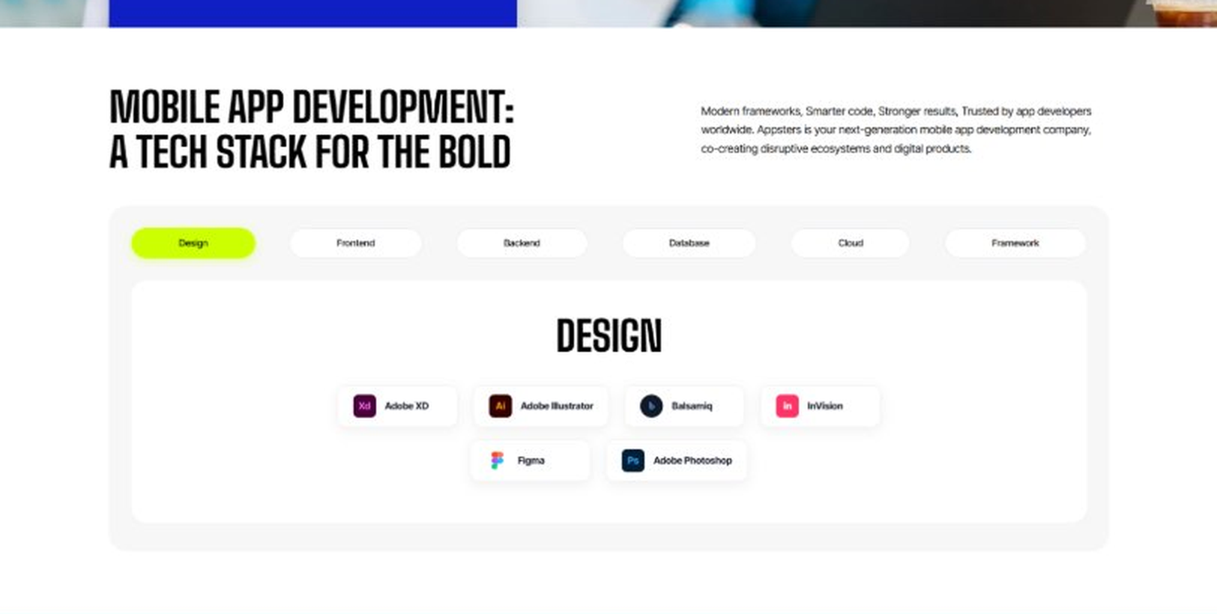
Current live page, www.appsters.io/industry
 | DETAIL
Status | New copy applied
Build Notes | Live block holds 6 category tabs with tool logos. New copy supplies the heading and paragraph, the tab contents stay as they are.
Copy For This Fold
PAGE ELEMENT | COPY (WORD FOR WORD)
H2 (Section Heading) | Technology Stack That Powers High-Performance Real Estate Applications
Body Copy | Our engineering foundation supports live MLS sync, heavy media traffic, and platform-wide scalability. Through our Real Estate application development services, we use Swift, Kotlin, Flutter, React Native, Node.js, MLS and IDX integration protocols, and secure cloud infrastructure alongside AI-driven pricing engines. Every stack decision reinforces speed, accuracy, and long-term flexibility so your platform can grow without a rebuild.
FOLD 18: Process
Process: App Development Process
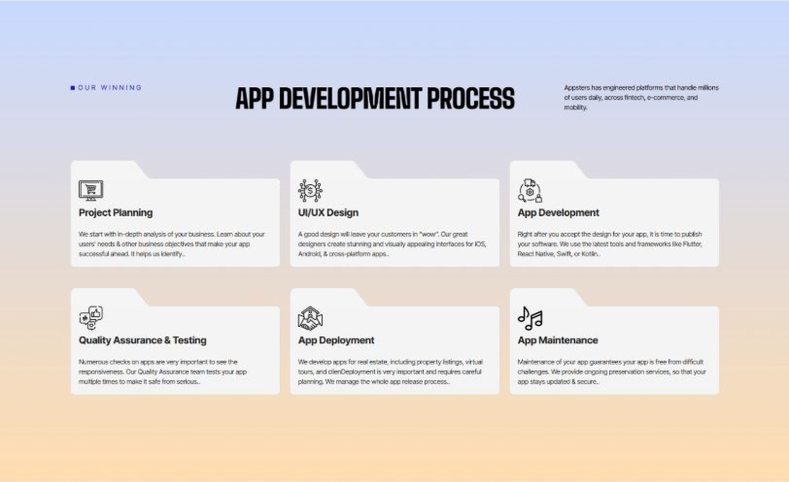
Current live page, www.appsters.io/industry
 | DETAIL
Status | New copy applied
Build Notes | Live block holds 6 step cards. New copy holds 8 steps. Either widen the block to 8 or merge two steps.
Copy For This Fold
PAGE ELEMENT | COPY (WORD FOR WORD)
H2 (Section Heading) | Real Estate App Development Process Built For Platforms That Actually Ship
Body Copy | A real estate platform needs more than good photos. It needs structure, clarity, and a process engineered for accuracy, speed, and trust from day one. Our Real Estate app development process aligns product goals with technical roadmaps so every phase moves with intention.
Step 1 Heading | App Idea & Research
Step 1 Copy | Every project begins with structured discovery, where our teams map buyer behavior, agent workflows, and local market data structures. We benchmark performance against existing platforms and define what will actually shorten time to close. By the time research closes, the product's purpose, risks, and growth path are already clear.
Step 2 Heading | Strategic Planning & Consultation
Step 2 Copy | Here we translate research into a measurable plan. Our strategists define the technical architecture, MLS integration needs, and delivery milestones needed to build your AI Real Estate mobile app the right way, from the first sprint.
Step 3 Heading | Wireframing & Prototyping
Step 3 Copy | We turn ideas into tangible user journeys. Wireframes capture listing search flows, agent dashboards, and buyer interaction patterns in a visual structure stakeholders can react to before a single line of code gets written.
Step 4 Heading | App Development
Step 4 Copy | This is where engineering takes over. Our developers implement listing sync, media handling, and transaction tools with the same discipline a food app development company applies to order accuracy and uptime. Development stays sprint-driven and transparent throughout.
Step 5 Heading | Expert QA & Testing
Step 5 Copy | Quality assurance covers far more than bug hunting. We validate MLS sync accuracy, media loading under real network conditions, and cross-device behavior. Only stable, predictable behavior earns approval to move forward.
Step 6 Heading | App Launch
Step 6 Copy | Launch is a coordinated rollout, not a leap of faith. We manage store compliance, metadata strategy, and final performance checks so your platform enters the market ready to hold real listing traffic.
Step 7 Heading | Deployment
Step 7 Copy | Our deployment pipelines are built for consistency and safety. We configure cloud infrastructure, optimize for high-resolution media at scale, and calibrate autoscaling so your app performs the same for 100 listings as it does for 100,000.
Step 8 Heading | Maintenance & Support
Step 8 Copy | Post-launch, we keep monitoring listing sync accuracy, refining search logic, patching vulnerabilities, and responding to new MLS or app store requirements, so your platform keeps improving long after day one.
Source document note: Process fold, design TBD after content
FOLD 19: Blog Posts
Blog Posts: Our Related Blog Posts
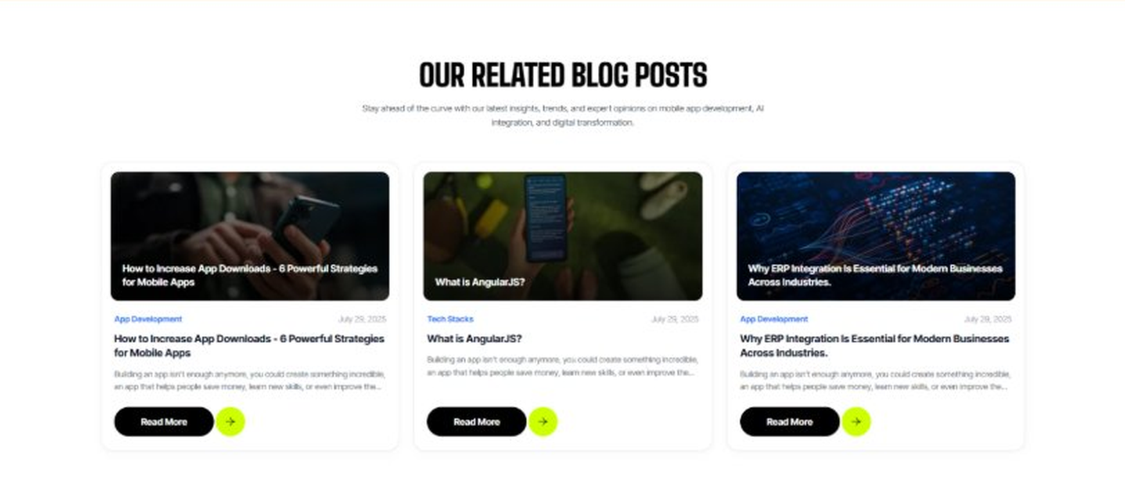
Current live page, www.appsters.io/industry
 | DETAIL
Status | No copy change
Build Notes | No new copy in the source document for this fold. Keep the live block exactly as it is.
FOLD 20: FAQs
FAQs: Your Questions, Our Clarity
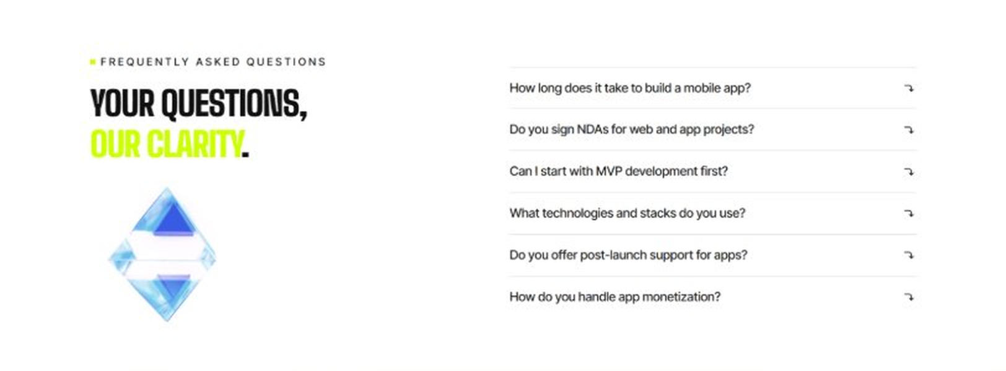
Current live page, www.appsters.io/industry
 | DETAIL
Status | New copy applied
Build Notes | Live block holds 6 accordion rows. New copy holds 6 questions and answers. Clean one to one fit.
Copy For This Fold
PAGE ELEMENT | COPY (WORD FOR WORD)
H2 (Section Heading) | Frequently Asked Questions
FAQ 1 Question | How long does it typically take to build a fully functional real estate app?
FAQ 1 Answer | Timelines depend on MLS integration complexity, portfolio size, and feature scope. Most projects take 12 to 20 weeks for a stable release, including design, engineering, QA, and pilot testing. As a real estate app development company, we provide clear milestones from day one.
FAQ 2 Question | Can Appsters build an AI Real Estate app with smart pricing and matching?
FAQ 2 Answer | Yes. We build AI Real Estate apps with pricing prediction, lead scoring, and automated buyer matching baked into the core architecture, not added as an afterthought.
FAQ 3 Question | Do you support in-app commerce features as a food delivery app development company would?
FAQ 3 Answer | Absolutely. Many of our Real Estate app developers have direct experience building amenity and delivery flows for residential communities, so we can embed commerce features directly into your resident app.
FAQ 4 Question | What makes Appsters different from other Real Estate mobile app development company options?
FAQ 4 Answer | We treat listing accuracy, compliance, and speed as core product decisions, not add-ons. Most Real Estate app development companies focus on UI first and scale later. We do both from the start.
FAQ 5 Question | Can you handle sudden traffic spikes during peak selling season?
FAQ 5 Answer | Yes. Our architecture is stress-tested for exactly this kind of load, so a seasonal surge becomes a manageable event instead of a downtime incident.
FAQ 6 Question | What ongoing support do you provide after launch?
FAQ 6 Answer | Our Real Estate app development services include post-launch monitoring, feature updates, MLS sync checks, and infrastructure scaling, so your platform keeps improving long after release.
FOLD 21: Locations
Locations: Our Global Presence
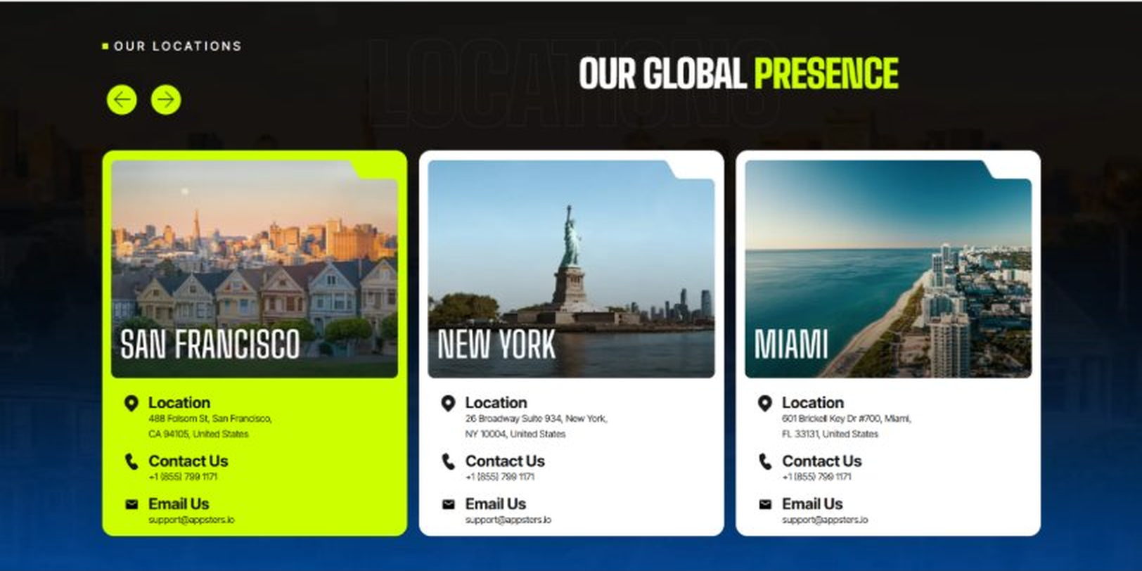
Current live page, www.appsters.io/industry
 | DETAIL
Status | No copy change
Build Notes | No new copy in the source document for this fold. Keep the live block exactly as it is.
FOLD 22: Contact Form
Contact Form: Connect With Us
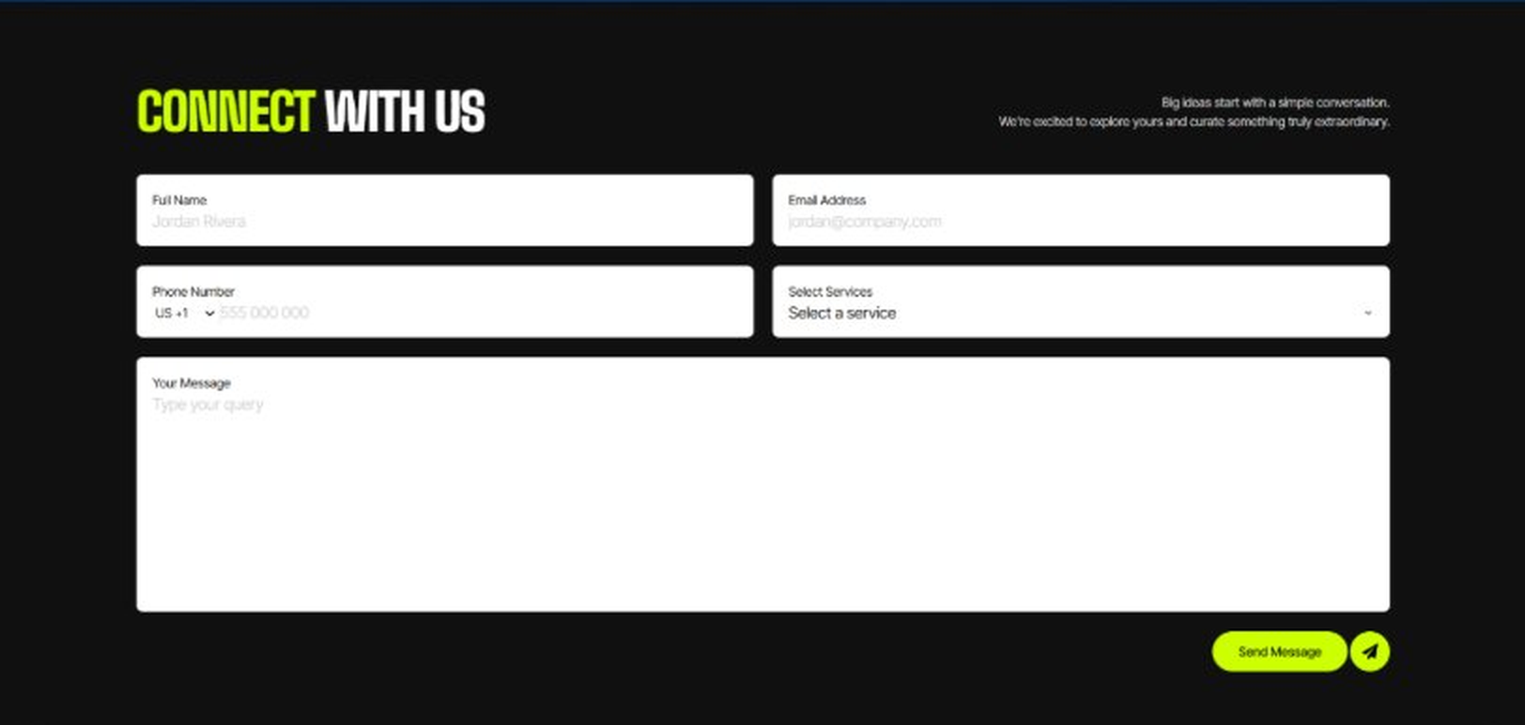
Current live page, www.appsters.io/industry
 | DETAIL
Status | No copy change
Build Notes | No new copy in the source document for this fold. Keep the live block exactly as it is.
FOLD 23: Footer
Footer
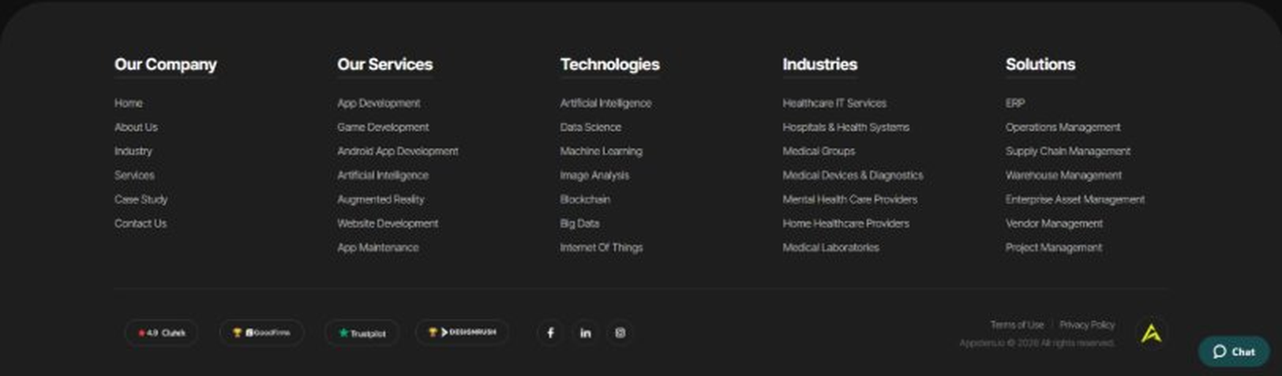
Current live page, www.appsters.io/industry
 | DETAIL
Status | No copy change
Build Notes | No new copy in the source document for this fold. Keep the live block exactly as it is.
NEW BLOCKS REQUIRED
The three blocks below are in the source content but have no matching section anywhere on the current /industry page. Each one needs a new block built.
NEW BLOCK: Distinct Features That Set Our Real Estate Apps Apart
 | DETAIL
Status | No equivalent block on the live page
Placement | Suggested placement: directly after Fold 5, reusing the services card grid styling.
Copy For This Block
PAGE ELEMENT | COPY (WORD FOR WORD)
H2 (Section Heading) | Distinct Features That Set Our Real Estate Apps Apart
Feature 1 Heading | Dashboard & Admin Panel
Feature 1 Copy | A centralized control center gives your team visibility into listing performance, lead activity, and portfolio health without digging through raw data.
Feature 2 Heading | Push Notifications
Feature 2 Copy | Smart, behavior-based notifications alert agents and buyers to new matches and price changes at the right moment instead of burying them in noise.
Feature 3 Heading | Digital Menu
Feature 3 Copy | A structured digital catalog lets buyers browse property types, amenities, and neighborhoods without getting lost in an endless listing feed.
Feature 4 Heading | Order Tracking
Feature 4 Copy | Real-time order tracking keeps tenants and buyers informed on maintenance requests and document status without repeated calls to the office.
Feature 5 Heading | Real Estate Integration
Feature 5 Copy | Direct MLS and third-party listing syndication keeps your property data consistent everywhere it appears, without manual re-entry across platforms.
NEW BLOCK: Industries We Serve
 | DETAIL
Status | No equivalent block on the live page
Placement | Suggested placement: directly after Fold 10, as a card grid rather than tabs.
Copy For This Block
PAGE ELEMENT | COPY (WORD FOR WORD)
H2 (Section Heading) | Industries We Serve
Body Copy | One Codebase. Infinite Industries. Our web, app, and AI solutions are built to perform, scale, and adapt while setting industry standards and redefining what's possible for businesses everywhere.
Industry 1 Heading | Fintech
Industry 1 Copy | We co-create secure, compliant fintech apps that simplify payments, investments, and trading, using the same transaction infrastructure we build for rent collection and closing costs.
Industry 2 Heading | Healthcare
Industry 2 Copy | We develop HIPAA-compliant healthcare apps that bridge doctors, patients, and data, applying the same secure document handling we use for lease agreements and disclosures.
Industry 3 Heading | Education
Industry 3 Copy | Our education apps gamify learning and power virtual classrooms, borrowing the same scheduling and communication tools we use for property showings.
Industry 4 Heading | Automotive
Industry 4 Copy | From fleet dashboards to car rental apps, we digitize automotive operations using the same location and inventory logic we build for property listings.
Industry 5 Heading | Music
Industry 5 Copy | We create streaming apps and artist marketplaces, applying the same media-heavy infrastructure we use to deliver high-resolution property photos and virtual tours.
Industry 6 Heading | Social Media
Industry 6 Copy | We build social platforms that are scalable and sticky, drawing on the same engagement mechanics we use to keep buyers browsing listings longer.
Industry 7 Heading | Logistics
Industry 7 Copy | We power logistics apps with route optimization and real-time tracking, using the same infrastructure behind our property maintenance dispatch tools.
Industry 8 Heading | Ecommerce
Industry 8 Copy | We build ecommerce apps with frictionless checkouts and AI product recommendations, drawing on the same matching logic we use to connect buyers with the right listings.
NEW BLOCK: Advanced Technologies That Power Our Real Estate Apps
 | DETAIL
Status | No equivalent block on the live page
Placement | Suggested placement: directly after Fold 17, reusing the services card grid styling.
Copy For This Block
PAGE ELEMENT | COPY (WORD FOR WORD)
H2 (Section Heading) | Advanced Technologies That Power Our Real Estate Apps
Body Copy | As a real estate app development company built around what's next, we don't stop at listings and photos. Every real estate app developer on our team stays current with tools that keep platforms competitive, from AI pricing models to live commerce. Unlike most real estate app development companies still catching up on food ordering app development trends inside resident apps, we're already building AI-based real estate apps with these capabilities baked in.
Technology 1 Heading | AI Integrated Real Estate Apps
Technology 1 Copy | We build AI Integrated Real Estate Apps with pricing prediction, lead scoring, and automated matching, helping agents focus on the leads most likely to close.
Technology 2 Heading | Payment Gateway Integration
Technology 2 Copy | Secure, PCI-compliant payment gateway integration lets your platform handle rent collection, deposits, and application fees without third-party friction.
Technology 3 Heading | Cloud Solutions
Technology 3 Copy | Our cloud solutions keep media-heavy platforms fast and reliable, with autoscaling infrastructure built to absorb seasonal listing traffic spikes.
Technology 4 Heading | MVP For Real Estate Apps
Technology 4 Copy | When you need to validate an idea fast, our MVP for Real Estate Apps approach gets a functional, testable product into agents' hands without a twelve-month build cycle.
Technology 5 Heading | API Integration
Technology 5 Copy | We connect your platform to MLS databases, title services, and other real estate ecosystems through clean, well-documented API integration.

